Naïve Bayes | 1
Demo Weather Dataset | 1
Method 1: Bag of Words | 1
Method 2: Bag of Words with Weights | 2
BBC Text Classification | 3
Method 1: Bag of words | 3
Method 2: Bag of words with importance | 3
Method 3: Checking if a word exists or not | 4
Mnist Digit Dataset | 5
Method 1: Counting displayed pixels | 5
Method 2: Accumulating pixel values | 6
Method 3: Counting displayed pixels by row | 7

Naïve Bayes

Demo Weather Dataset

Method 1: Bag of Words

In the bag-of-words method, we simply tallied how often each feature (such as "continent=Africa") appeared within each temperature group (cold, hot, or normal). From these counts, we derived probability values. These probabilities were then utilized to forecast the temperature for a given combination of features.

This approach allows for a straightforward representation of data by counting the occurrences of specific features within each temperature group. By deriving probability values from these counts, it becomes possible to make temperature predictions based on the combination of features present.

It gave a maximum Accuracy of about 69%

We tried different values for the Laplace smoothing ranging from 0.1 to 100

The accuracy results are summarized in the graph below
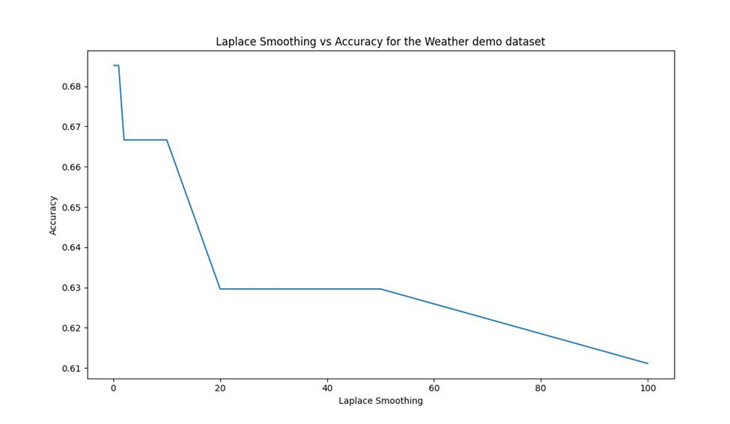

The Accuracy seems to decrease with increased Laplace Smoothing value.

1

Method 2: Bag of Words with Weights

Similar to method 1 but instead of simply using the probability of a given feature appearing in a certain group, that probability was first multiplied by a weight for that given type of feature. We decided (from common sense and some trial and error) that Season, location and windspeed should have higher weights compared to the rest.

This slightly increased the accuracy to around 72%. (This may or may not work for other datasets. A bigger dataset is required to asses that)

The Laplace smoothing vs Accuracy graph for this method is given below
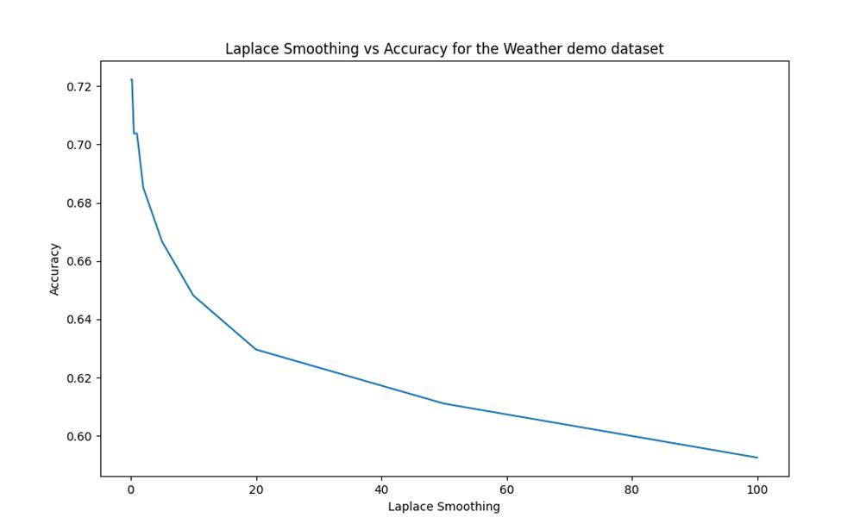

Similar to method 1, the Accuracy seems to decrease with increased Laplace Smoothing value.

2

BBC Text Classification

Method 1: Bag of words

In this approach, we maintained a count for each word in the dataset, noting how frequently it appeared in each of the five groups. This count information was used to determine the probability of a word occurring in a specific group. Subsequently, we utilized this probability table to perform Naïve Bayes classification. This method demonstrated high effectiveness, yielding an accuracy rate of approximately 96 percent.

We tried different Laplace smoothing values ranging from 0.1 to 500. And as expected, we noticed a decrease in accuracy as the smoothing value increased.

The results are summarized in the graph below
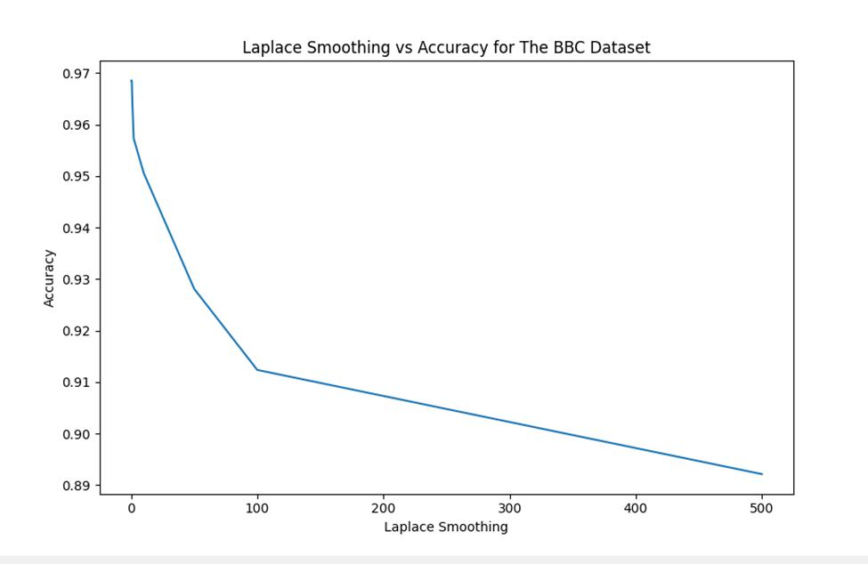

Method 2: Bag of words with importance

In this method, we count the word’s occurrence in a given group similar to method 1. But in addition to that we also calculate the importance of a word for classification.

We calculate the importance of words by sorting them based on the difference of the maximum and minimum probability of it occurring in a group (the range of probability for that word). The

3

reasoning behind this is that if a word has a high probability of occurring in one group but a low probability in another group that means the occurrence or non-occurrence of this word gives us a better insight into what group the whole article or document might belong to. Therefore, we take the probability of this word more seriously.

This method gave a slightly higher maximum accuracy of approximately 98%.

The Accuracy vs Laplace smoothing value graph is found below
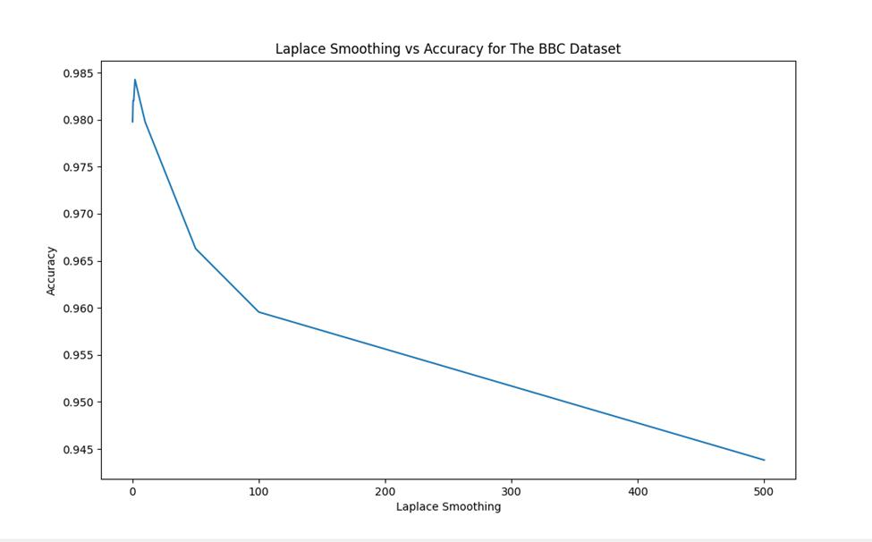

For this method, the accuracy attains its maximum of 98% at a Laplace value of 2 and decreases going in either direction.

Method 3: Checking if a word exists or not

In this approach, we verified whether a word is present in a specific group or not. We marked each word based on its existence in the group. When classifying, we examined each word in a document and incrementally increased the probability of the document belonging to a group if the word was found in that group. Regrettably, this method proved to be ineffective, resulting in an accuracy rate of approximately 22%.

4

Mnist Digit Dataset

Method 1: Counting displayed pixels

In this approach, we tabulated the occurrences of pixels with values greater than zero for each number. Using these counts, we calculated the probability of a pixel being on given a specific number. With this probability table in hand, we applied the Naïve Bayes method. As a result, the test accuracy reached approximately 84%.

The reasoning behind using this method is based on the assumption that when numbers are written in the same location (typically the center), they tend to activate the same pixels consistently. By counting and analyzing which pixels are frequently illuminated by each number, we can derive probabilities. In other words, by observing the patterns of pixel activation for different numbers, we can make inferences about the likelihood of specific pixels being illuminated for a given number.

We tried different Laplace smoothing values. The results are in the line graph below.

To achieve faster runtime for the test, we reduced the number of training samples to 10,000 and the number of test samples to 100. As a consequence of this reduction in data size, the accuracy decreased from the previously mentioned 84%
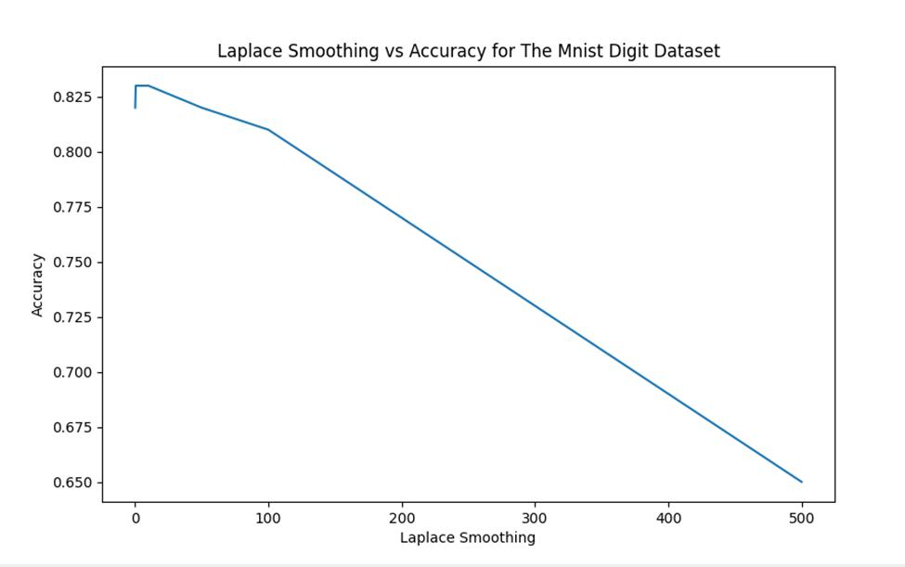

5

The Accuracy result seems to increase as the Laplace smoothing value rises from 0.1 to 1 but going after that the accuracy begins to decrease.

Therefore, a Laplace Smoothing value of around 1 or 2 is recommended.

Method 2: Accumulating pixel values

Similar to Method 1, this approach involves accumulating the pixel values for each number instead of counting non-zero pixels. The accumulated value for each pixel is divided by the maximum possible accumulated pixel values for that number. This calculation generates a probability table that is used for Naïve Bayes classification, as mentioned previously.

The reason for using this method is the same as method 1 except that by accounting for the values of the pixels, we get more information.

This method yielded a slightly higher accuracy of 86%

The Accuracy vs Laplace Smoothing value graph is given below
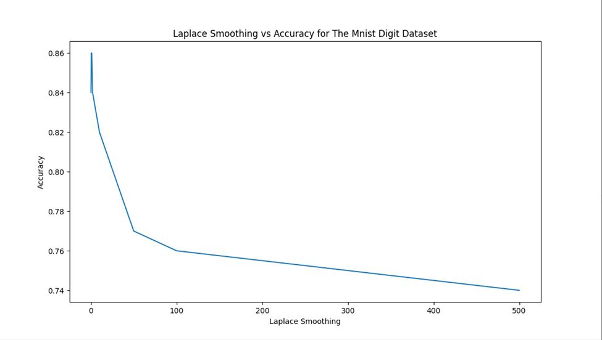

Similar to method 1 the Accuracy attains a peak of 86% at Laplace Smoothing values of 0.5 and 1.

Therefore, those values are recommended.

6

Method 3: Counting displayed pixels by row

In this alternative approach, the method involves counting the number of lit pixels in each row of the image for each digit. By tallying the lit pixels in each row, valuable information about the distribution and arrangement of foreground pixels within each digit is obtained. The counts are then used to calculate the probabilities of lit pixels occurring in each row for each digit, resulting in a probability table. During classification, the counting process is applied to a new image, and the probabilities from the table are used to determine the most likely digit. This method provides a spatial understanding of the digit's shape and structure.

This method also improves space efficiency of the algorithm since the feature vector has a length of 28 instead of 784 like the previous methods.

This method resulted in a test accuracy of approximately 66%.

As with the other methods, we experimented with different values of Laplace Smoothing. The results are summarized in the graph below.
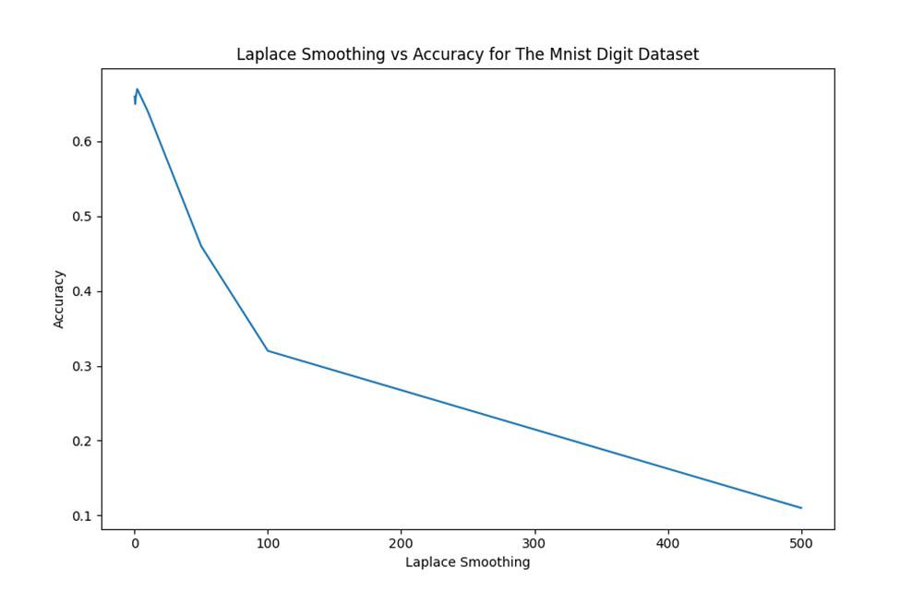

7

